**Market Analysis Report for National Clothing Chain**

* This report provides a comprehensive summary of the conducted analysis’ results. Furthermore, it presents answers to the provided analysis questions, findings of the analysis, and a final recommendation.
* **Analysis Questions:**

1. **What is the correlation (R2 value) between sales and income?**

The figure below shows the correlation coefficient between sales and income. It shows that the R2 value=0.78. Therefore, there is a medium positive correlation.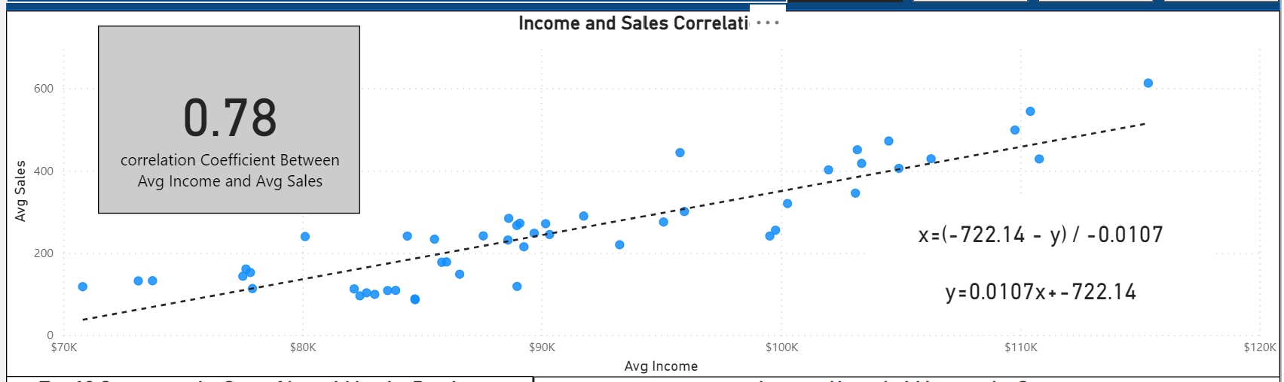**[1]**

1. **What is the correlation (R2 value) between customer ratings and product return rate?**

The figure below shows the correlation coefficient between customer ratings and product return rate. It shows that the R2 value=0.50. Therefore, there is a medium positive correlation.

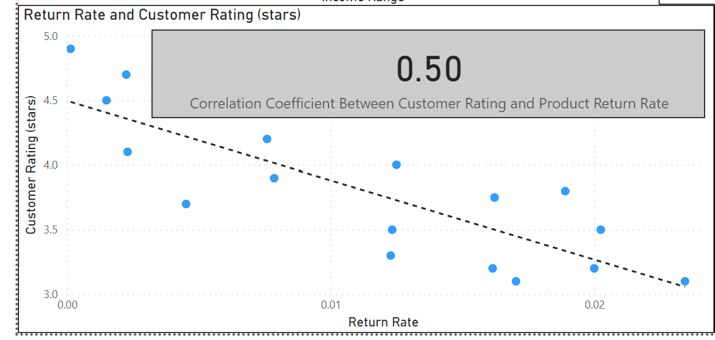

1. **What are the linear regression formulas to predict customer income from customer sales?**
2. **Which customer do you predict has the highest income?**

The Figure below shows the top 10 customers by predicted income. John Little is the top 1 with a predicted income of $558,143.93. Moreover, John Little spent the most during the last 6 Months as shown below in the figure. He spent $5,250.

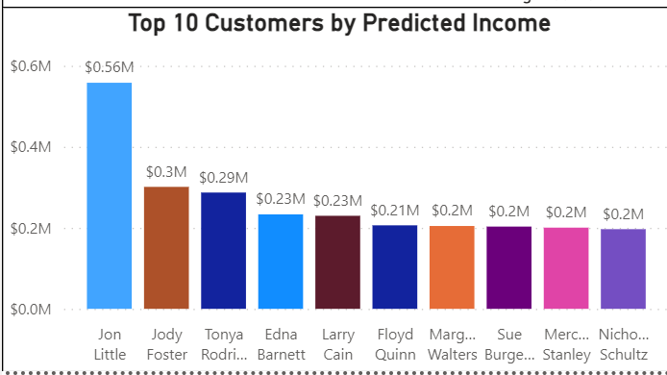

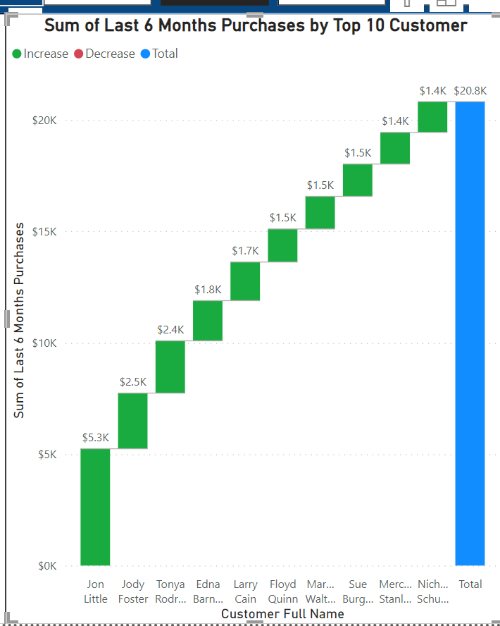

1. **Which product will be advertised the most?**

Based on my analysis, most customers belong to the middle/upper middle classes. The figures below show the most suitable product for the stated customer category. Therefore, the sweater would be the most advertised product.

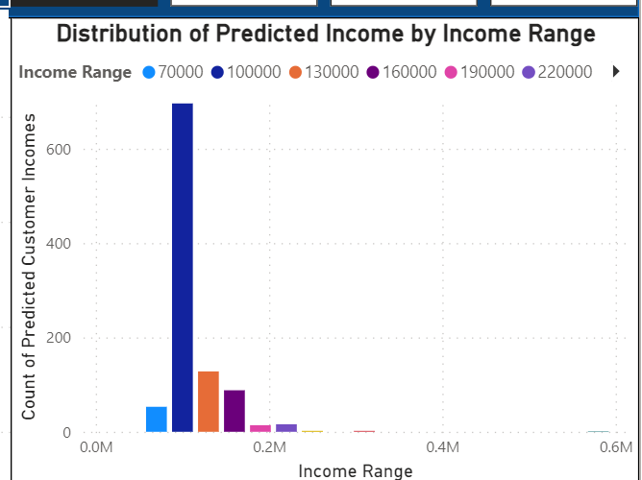

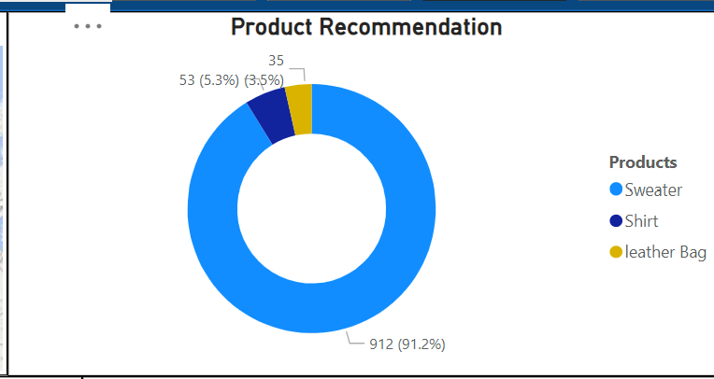

* **Recommendation**

According to my analysis, most of the customers belong to the middle/upper middle classes. It would be advantageous to target the states with the highest percentage of middle/upper middle-class individuals. Furthermore, developing a marketing campaign to advertise Sweater could be highly beneficial.

1.